SCRIPTING TASK

https://docs.google.com/document/d/1D9Q2jU2RGmpI2wp8vkrmRfOiGtNf0FQxyYeJ3IZShl4/edit

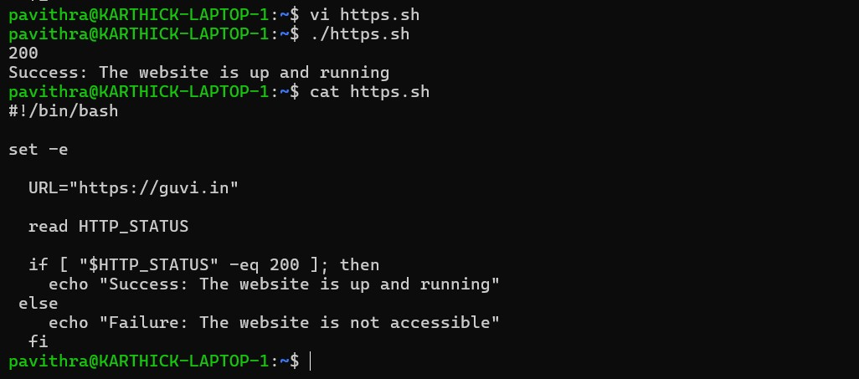

SED command

